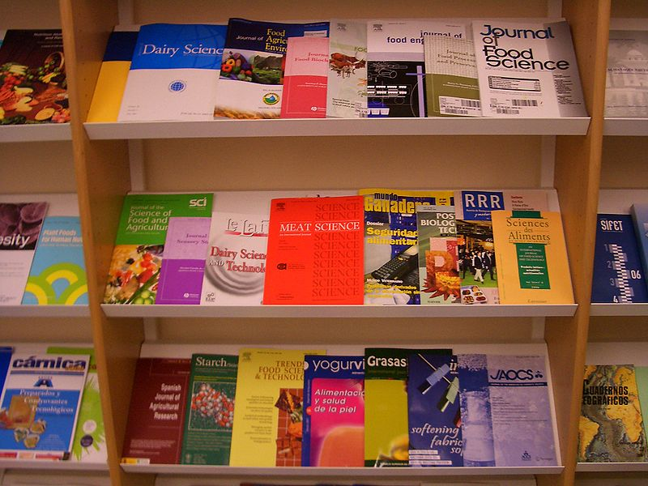 ACADEMIC JOURNALS

RYANA CALENDARS is selling wonderful ACADEMIC journals !at reasonable prices. It contains beautiful and designable covers!

RS 500